WEEK 2 TASK: ADVANCED DATA VISUALIZATION AND STORYTELLING WITH PYTHON

Indian E-Commerce Sales Analytics Dataset
Internship: Yuva Intern – Virtual Data Science with Python Apprentice Intern
Source: Kaggle
Tools: Python, Jupyter Notebook, Pandas, Matplotlib, Seaborn, Squarify

1. INTRODUCTION

1.1 Task Objective
The objective of this Week 2 task is to move beyond basic analysis and focus on advanced data visualization and storytelling using Python. The goal is not only to generate charts, but to communicate meaningful business insights in a clear and structured way.
Using the Indian E-Commerce Sales Analytics Dataset from Week 1, this task builds a complete visual story covering:
- Revenue trends over time
- State-wise performance
- Customer segmentation
- Product category contribution
- Payment behavior patterns
- Coupon usage impact
Each visualization is designed to answer a specific business question.

1.2 Data Story Objective
The central question of this analysis is:
How does an Indian e-commerce platform perform across time, geography, customers, products, and payment behavior, and what business insights can be derived from the data?
The visualizations are organized as a connected story rather than as unrelated charts. Each visualization answers a specific business question and contributes to the overall understanding of the e-commerce platform.

2. DATA AND METHODOLOGY

2.1 Dataset Overview
The same Indian E-Commerce Sales Analytics Dataset used in Week 1 was used for this analysis.
The dataset contains three related tables:
Table | Records | Purpose
Customers | 40,000 | Customer demographics and purchasing information
Products | 2,000 | Product, pricing, category and rating information
Sales | 250,000 initially | Transaction-level information
After applying the Week 1 cleaning process, the sales dataset contained 249,995 valid records.

2.2 Data Preparation Steps
The Week 1 data-cleaning procedures were reapplied before creating the Week 2 visualizations.
The preparation included:
- Converting date columns into datetime format.
- Replacing missing coupon codes with No Coupon.
- Creating the Has_Review indicator.
- Removing transactions with negative Total_Amount.
- Using the cleaned customer, product, and sales tables for analysis.

2.3 Tools and Libraries
The following Python libraries were used:
- Pandas – data loading, transformation and aggregation
- Matplotlib – chart creation and customization
- Seaborn – statistical visualization
- Squarify – treemap visualization
- Jupyter Notebook – development and execution environment

2.4 Visualization and Storytelling Approach
Each visualization was selected according to the type of question being answered.
- Line charts were used to show changes over time
- Bar charts were used for comparisons
- Stacked bars were used to show composition
- Treemaps were used to represent revenue contribution across product categories
- Scatter/box plots were used to examine the relationship and distribution of coupon-related order values.
Annotations were added to important charts to direct attention to significant findings.

3. VISUALIZATION 1 — MONTHLY REVENUE TREND

3.1 Visualization
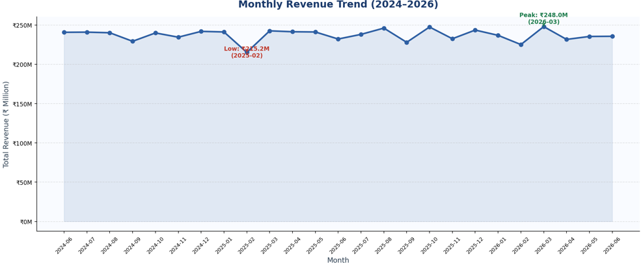Figure 1: Monthly Revenue Trend

3.2 Why This Chart?
A line chart was selected because it is effective for showing how revenue changes over time. It allows the highest and lowest revenue periods to be identified quickly and helps the audience understand the overall variation in monthly performance.
Annotations were included to highlight important points in the revenue trend.

3.3 Observation
The highest monthly revenue was recorded in March 2026, with revenue of: ₹248.03 million
The lowest monthly revenue was recorded in February 2025, with revenue of: ₹215.19 million
The difference between the highest and lowest monthly revenue was approximately: ₹32.84 million

3.4 Insight
Revenue varied across the observed period, with March 2026 recording the strongest monthly performance and February 2025 recording the lowest.
The visualization provides a clear view of revenue fluctuations and identifies periods that may require further investigation.

3.5 Business Implication
The business can use monthly revenue trends to identify high-performing periods and investigate the factors associated with them. This can support future planning of promotions, inventory, staffing, and marketing activities.

4. VISUALIZATION 2 — TOP STATES BY REVENUE

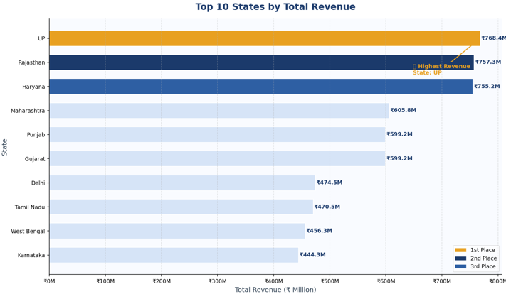
4.1 Visualization
Figure 2: Top States by Total Revenue

4.2 Why This Chart?
A horizontal bar chart was selected because it provides a clear comparison of revenue across states and makes it easy to rank the highest-performing geographical markets.

4.3 Observation
The top three revenue-generating states were:

Rank | State | Revenue
1 | UP | ₹768.35 million
2 | Rajasthan | ₹757.29 million
3 | Haryana | ₹755.22 million
UP recorded the highest total revenue in the dataset.

4.4 Insight
Revenue is not distributed equally across all states. A small group of states contributes a significant portion of the total revenue, with UP, Rajasthan, and Haryana being the strongest markets among the top-ranked states.

4.5 Business Implication
The business can prioritize high-performing states for regional marketing, customer acquisition, delivery infrastructure, and inventory planning.
At the same time, lower-performing regions could be investigated to understand whether differences are caused by customer demand, availability, logistics, or market reach.

5. VISUALIZATION 3 — CUSTOMER AGE GROUP AND TIER ANALYSIS

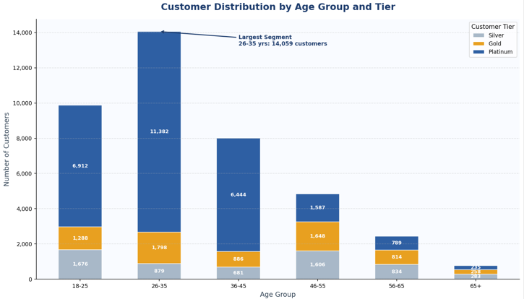
5.1 Visualization
Figure 3: Customer Distribution by Age Group and Customer Tier

5.2 Why This Chart?
A stacked bar chart was selected because it allows two customer characteristics — age group and customer tier — to be studied together.
The chart shows both the overall size of each age group and how Silver, Gold, and Platinum customers are distributed within each group.

5.3 Observation
- The largest customer age group was: 26–35 years — 14,059 customers
- The most common customer tier was: Platinum — 27,349 customers

5.4 Insight
The customer base is strongly represented by customers aged 26–35. Platinum customers also form the largest customer tier, indicating that a substantial portion of the customer base belongs to the highest membership level represented in the dataset.
The combination of age group and customer tier provides more useful information than examining either variable independently.

5.5 Business Implication
The business can develop targeted campaigns for the 26–35 customer segment and explore loyalty strategies for Platinum customers.
Further analysis could examine whether customer tier is associated with total spending, order frequency, or product preferences.

6. VISUALIZATION 4 — PRODUCT CATEGORY PERFORMANCE

6.1 Visualization

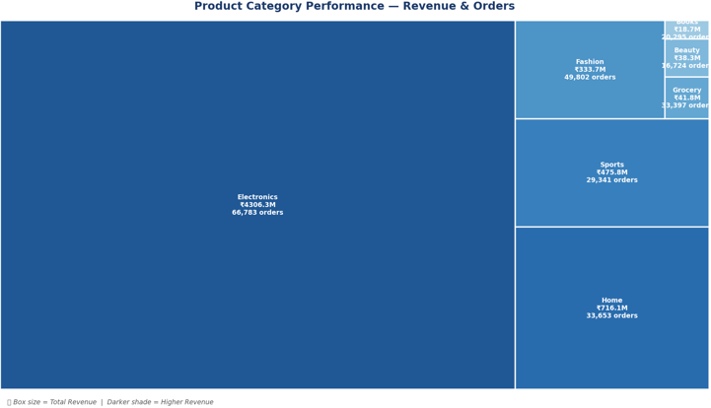
Figure 4: Product Category Performance — Revenue and Orders

6.2 Why This Chart?
A treemap was selected because it provides an effective view of part-to-whole relationships across multiple product categories.
In this visualization:
- Box size represents total revenue
- Shading represents revenue level
- Labels display category revenue and order count
This allows the audience to identify dominant product categories quickly.

6.3 Observation
The top three product categories by revenue were:
Rank | Category | Revenue
1 | Electronics | ₹4,306.35 million
2 | Home | ₹716.13 million
3 | Sports | ₹475.84 million
Electronics generated substantially more revenue than the other leading categories.

6.4 Insight
Electronics is the dominant revenue-generating product category in the dataset. Its revenue contribution is considerably larger than that of Home and Sports.
This indicates that product category has a strong relationship with the overall revenue composition of the e-commerce platform.

6.5 Business Implication
The business can prioritize inventory availability, product selection, and promotional strategies within the Electronics category.
At the same time, the performance of smaller categories can be analyzed to identify opportunities for growth and diversification.

7. VISUALIZATION 5 — PAYMENT MODE BY ORDER STATUS

7.1 Visualization
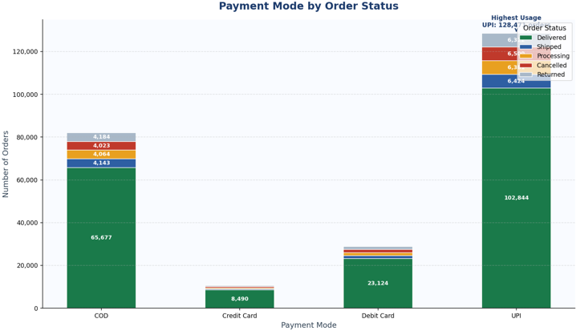Figure 5: Payment Mode by Order Status

7.2 Why This Chart?
A stacked bar chart was selected to show both the total usage of each payment method and the composition of order statuses within each payment mode.
This provides more information than a simple payment-method frequency chart because it connects payment behavior with operational order outcomes.

7.3 Observation
The payment-mode distribution was:
Payment Mode | Orders | Share
UPI | 128,471 | 51.4%
COD | 82,091 | 32.8%
Debit Card | 28,856 | 11.5%
Credit Card | 10,577 | 4.2%
UPI was the most commonly used payment method.

7.4 Insight
UPI accounts for more than half of all transactions, making it the dominant payment method.
COD also represents a significant share of transactions, while debit-card and credit-card transactions account for smaller proportions.
The stacked visualization additionally shows how different order statuses are distributed within each payment mode.

7.5 Business Implication
The business should maintain a strong and reliable UPI payment experience because of its high transaction share.
COD should also continue to be supported because it represents a substantial portion of orders. Payment-mode and order-status combinations can be studied further to identify possible operational differences.

8. VISUALIZATION 6 — COUPON DISCOUNT IMPACT ON ORDER VALUE

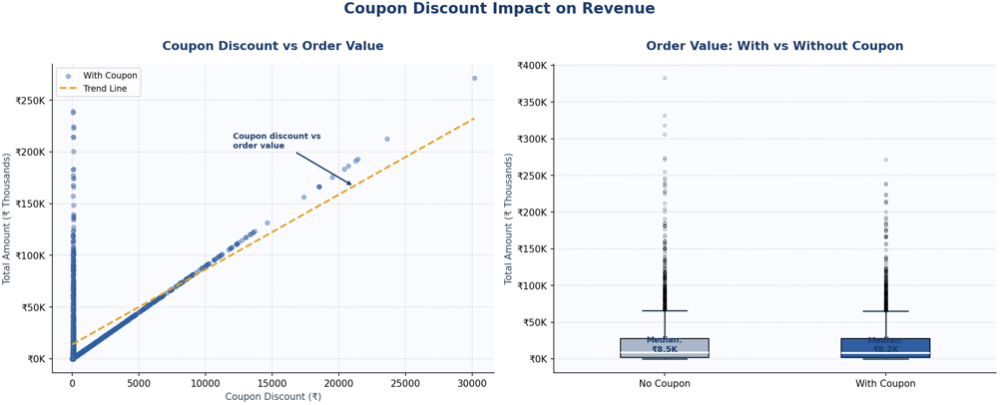
8.1 Visualization
Figure 6: Coupon Discount Impact on Order Value

8.2 Why This Chart?
A combination of a scatter plot and box plot was used to examine coupon usage from two perspectives.
The scatter plot shows the relationship between coupon discount and order value, while the box plot compares the distribution of order values for transactions with and without coupons.
Using two complementary views provides a more complete understanding of the coupon relationship.

8.3 Observation
The median order value was:
With Coupon: ₹8,145.81
Without Coupon: ₹8,354.44
The difference was: ₹208.63 lower for orders with coupons

8.4 Insight
In this dataset, orders using coupons did not have a higher median order value than orders without coupons.
The median order value for transactions without coupons was slightly higher than that of transactions with coupons.
Therefore, coupon usage alone cannot be interpreted as increasing order value based on this analysis.

8.5 Business Implication
The business should evaluate coupon campaigns using additional measures such as profit margin, repeat purchases, customer acquisition, and total customer value rather than order value alone.
Further analysis would be required to determine whether coupons improve customer retention or generate other business benefits.

9. BUSINESS IMPLICATIONS
The combined visual analysis provides several practical implications for the e-commerce business.

9.1 Focus on Strong Revenue Markets
UP, Rajasthan, and Haryana are among the highest-revenue states. These markets can receive greater attention in regional marketing, logistics, and customer acquisition strategies.

9.2 Prioritize High-Value Product Categories
Electronics is the dominant revenue-generating category. Maintaining adequate inventory and analyzing customer preferences within this category could help protect a major revenue source.

9.3 Strengthen Digital Payment Experience
UPI accounts for approximately 51.4% of transactions. A smooth, secure, and reliable UPI checkout experience should therefore remain a priority.

9.4 Target Core Customer Segments
The 26–35 age group is the largest customer segment, while Platinum is the most common customer tier. These customers could be considered for targeted loyalty and promotional strategies.

9.5 Evaluate Coupons Beyond Order Value
The coupon analysis shows that coupon users did not have a higher median order value in this dataset. Promotional effectiveness should therefore be evaluated using broader measures such as profitability, repeat purchases, and customer retention.

9.6 Use Revenue Trends for Planning
Monthly revenue variation can help the business identify high- and low-performing periods and improve planning for inventory, marketing campaigns, and operational resources.

10. CONCLUSION
This Week 2 project developed a visual data story using the Indian E-Commerce Sales Analytics Dataset.
Six visualizations were created to examine different aspects of e-commerce performance: monthly revenue, geographical revenue distribution, customer segments, product category performance, payment behavior, and coupon usage.
The visualizations were intentionally selected to match the type of business question being answered. Line charts were used to communicate trends over time, bar charts to compare states, stacked bars to show customer and payment compositions, a treemap to communicate category contribution, and a combination of scatter and box plots to explore coupon-related order values.
The analysis identified several important patterns. March 2026 recorded the highest monthly revenue, while UP was the highest-revenue state among the states analyzed. The 26–35 age group represented the largest customer segment, Platinum was the most common customer tier, and Electronics was the strongest product category by revenue. UPI was the dominant payment method, representing 51.4% of transactions.
The coupon analysis produced an important finding: coupon users did not have a higher median order value than non-coupon users. This demonstrates the importance of allowing the data to guide the interpretation rather than assuming that a business activity automatically produces a positive outcome.
Overall, the project demonstrates how effective visualization and storytelling can transform large datasets into clear, understandable, and actionable business information for both technical and non-technical audiences.

11. OVERALL DATA STORY
The visualizations tell a connected story about the e-commerce platform:
Revenue changes over time → Revenue is concentrated in specific states → The customer base has identifiable segments → Electronics dominates product revenue → UPI dominates payment behavior → Coupon usage does not automatically increase order value.
Together, these findings demonstrate how data visualization can move beyond displaying numbers and instead communicate a coherent business narrative.

